Headlight Notes 9

Our Exclusive Free Maintenance Service

"Got it... Maintenance Free Restorations?"

Factory new and restored plastic headlights all
Require Periodic Maintenance.
Don't be fooled by services advertising "MAINTENANCE FREE RESTORATIONS"

- Here is why WE CLEAR HEADLIGHTS is a better value than any other restoration service in Pinellas County.

To keep your beautifully restored headlights looking new for all of our private owners - We provide Free Maintenance Every 90 Days for one full year on all resurfaced lenses.

- Upon completion our office will schedule four free inspections of
- your headlights.

- Each visit we wash your headlight lenses, inspect them and apply a protective coat of premium quality sealant.
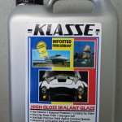
Applied Every 90 Days

- Our exclusive service will both restore your headlights to Showroom New and Keep them to looking beautiful for a long time.

